# Exercise: Exploring User-DeFined Functions

## Purpose: First time working with T-SQL’s UDFs

## Using the Chinook DB:

1. You’ve been asked by the company Social Committee to make a birthdays list for Chinook employees. Create a standard SELECT query that returns, in two fields, a list of each employee’s month of birth, as shown below. Note the format of the data, the column aliasing, and the sorting.

Hint: [MS Docs: Working with Dates](https://docs.microsoft.com/en-us/sql/t-sql/functions/date-and-time-data-types-and-functions-transact-sql?view=sql-server-2017)

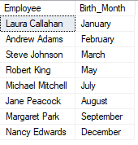

1. You take your query results to the committee director, but she’s not happy only knowing the birth months. She wants to know the full birthdays. Write another regular SELECT query to retrieve the birthdays, displayed in the exact date format specified:

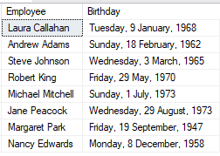

1. The social committee director is happy with the birthday list you provided, takes it and leaves to start planning who knows what. However, you know her well enough to know she’s probably going to lose the list, or forget about it, and come asking you for another birthday list next month.

Make a scalar user-defined function that you can use anytime to get the same birthday data, in the preferred format. The results will look identical to the previous step.

1. Write a SQL statement that uses the UDF from step 3 to retrieve the birthday records.
2. Create a table-valued UDF called **ufnGetFormattedCustomerRecords** that returns all customer data, with the following specifications:
   * If the customer belongs to a company, only show the company name, not the personal name.
   * The full address (Address, City, State, Country, PostalCode) should be integrated as a single field, with values separated by commas. If any part of the address is missing, do not include it. Yes, this means no extra spaces or commas in your output!
   * Hint: IsNull is your friend.
3. Write a SQL statement that uses the UDF from step 5 to retrieve every customer’s Email, Phone and the formatted data from the UDF.
   * Hint: You may need a JOIN…

